Project Description
In 1990 Dutch artist Theo Jansen invented the Strandbeest; wind-powered constructions that roamed the beaches of the Netherlands. This project is based on a motorized version of his invention. This project was originally radio-controlled, but over time it was repeatedly upgraded;;
- Convert to Arduino control - I got tired of using the RC controller and decided to have the Strandbeest follow a pre-programmed path.
- Add a superstructure with 7 rotating eyeballs and a brain - This was inspired by the Science Fiction writer E.E.Doc Smith whose Lensman series featured superior beings who were disembodied brains floating in nutrient baths. This idea was difficult to implement, so I settled for the superstructure shown. The missing 3 eyeballs are on the back.
- Add two audio channels with amplifiers, speakers, and sound effects - The cow and chicken sounds are self-explanatory, the Ack AcK! sounds are based on the movie "Mars Attacks".
- Replace the original 12V battery with two series 6V batteries and remove a 6V regulator to allow more power for servo motors.
- Add servo-controlled mouths that moved in sync with the sound effects - sounds need mouths to create them.
These modifications took place over a number of years, and may not yet be completed. At this point, the Arduino Uno is controlling 2 DC motors (motion), 9 servo motors (7eyeballs, 2 mouths) and 2 sound sources (a voice recorder and a sound card with cow and chicken sounds).

YouTube video
After many, many attempts, I couldn't get the video to embed, so there is a link $ here $
Strandbeest leg and crankshaft mechanism
The Strandbeest mechanism carries all of the rest of the project. This mechanism consists of a number of legs (6 minimum) driven by a crankshaft. Theo Jansen designed these legs to have a long, flat stride. This brilliant man published the ratios he used for the legs so that the rest of us can make our own.
﻿
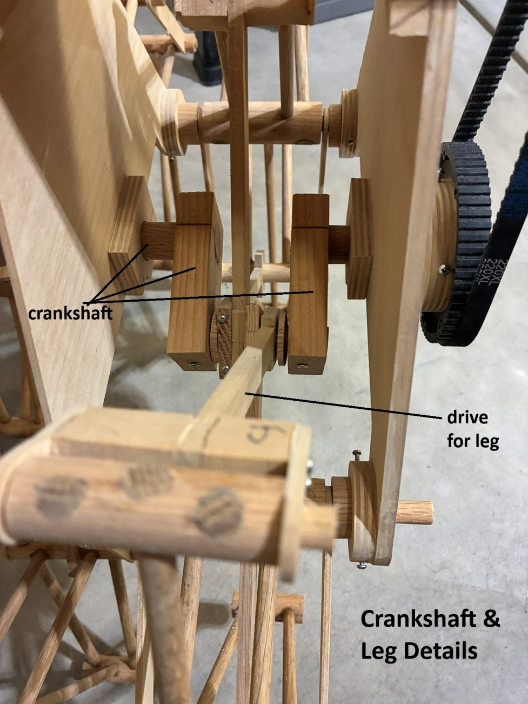
Crankshaft and Leg Details
PreviousNext
I made a wooden jig with pegs or holes at the locations shown in one of the slide above and constructed the legs for this project using mostly oak dowels
The crankshafts (one for each set of 3 legs) were made out of a 1" diameter oak dowel with 1" X 2" extensions glued into place. Once the glue dried, I sawed off the interior of the dowel. The original Strandbeest legs were made out of PVC tubing.
Motors, belts and pulleys.
This version of a Strandbeest has pretty high friction, even with parafin-coated bearing surfaces, so the driving motors need a lot of torque. This results in a slow speed. The Strandbeest can outrun a turtle with ease, but that's about it. The motors that are installed are 12VDC 30 RPM gear motors from Servo City. The drive mechanism is shown:
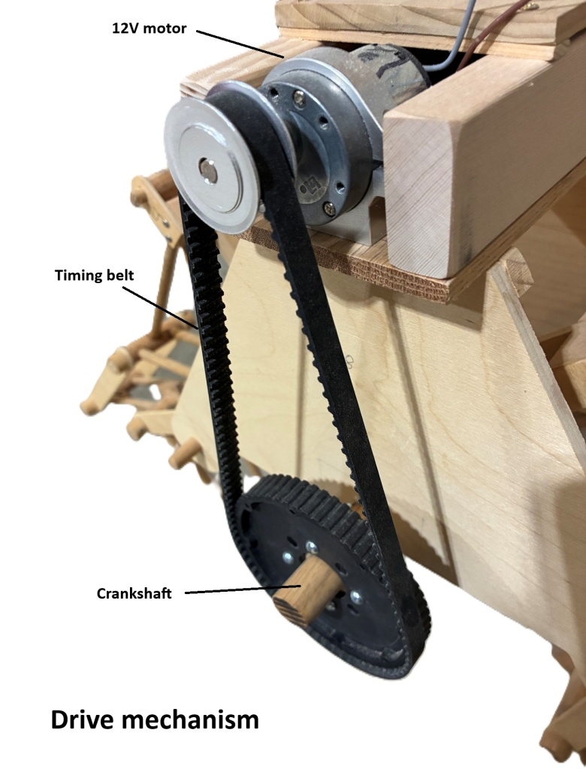
Motor driver
The dual motor driver is made by Actobotics. I'm using it in a mode where the pulse widths are set by the Arduino. A wider pulse width equals faster motor speed. The drivers can also reverse the motors direction.
Rotating Eyeballs
The eyeballs are each controlled with a low-power servo motor. They are made out of wooden balls that are painted. The eyeballs are pivoted with a brass rod and they have a slotted dowl in the rear for the servo arm pin. The servo arm rotates the eyeball as it swings.
﻿
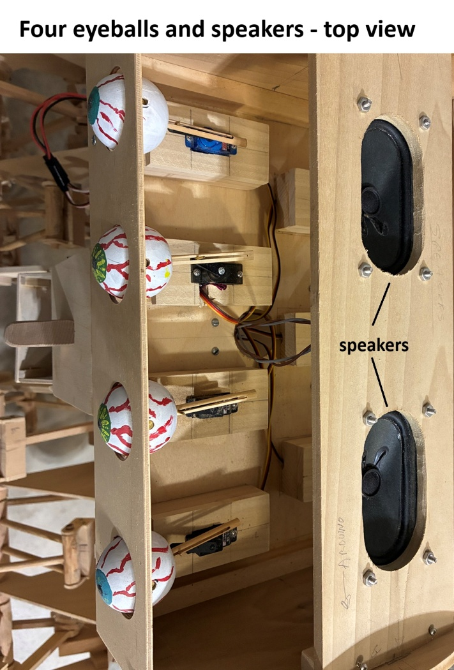
PreviousNext
Electronics layout
The electronics are assembled along the structure of the Strandbeest more or less following the circuit flow. The audio is a old design; it's pretty easy to use sound effects stored on a micro SD card now. There are lots of wires because the Arduino is controlling a lot of things.
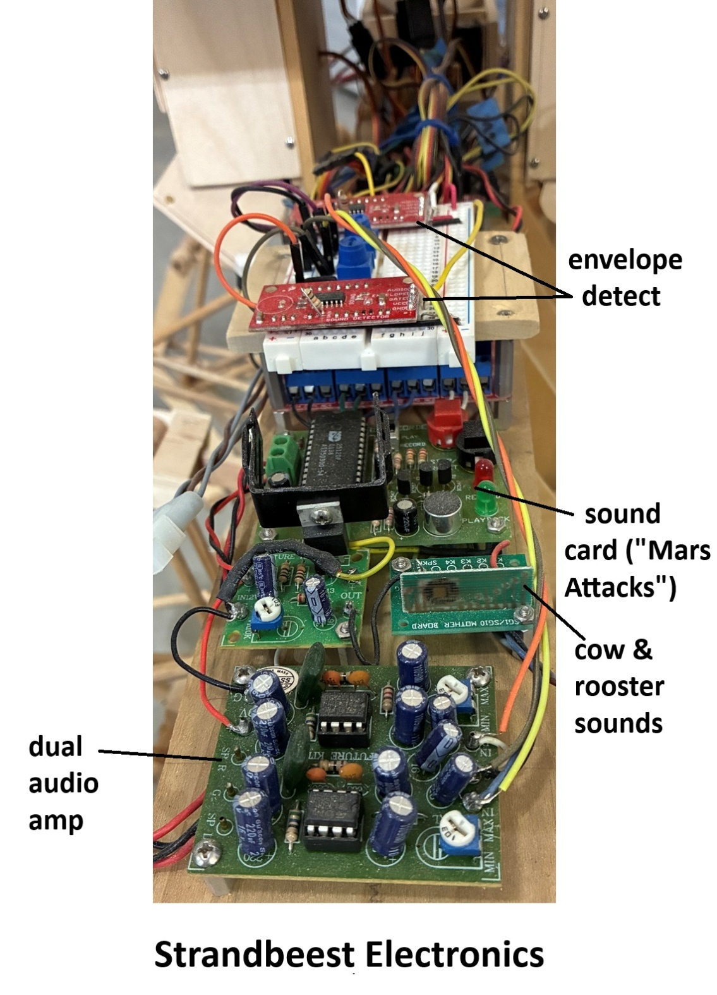

Audio
The audio consists of two separate channels, each of which is Arduino-controlled. A block diagram of the audio is shown below: The Arduino calculates the pulse width for the mouth servo motor according to a formula shown in the Program discussion below.
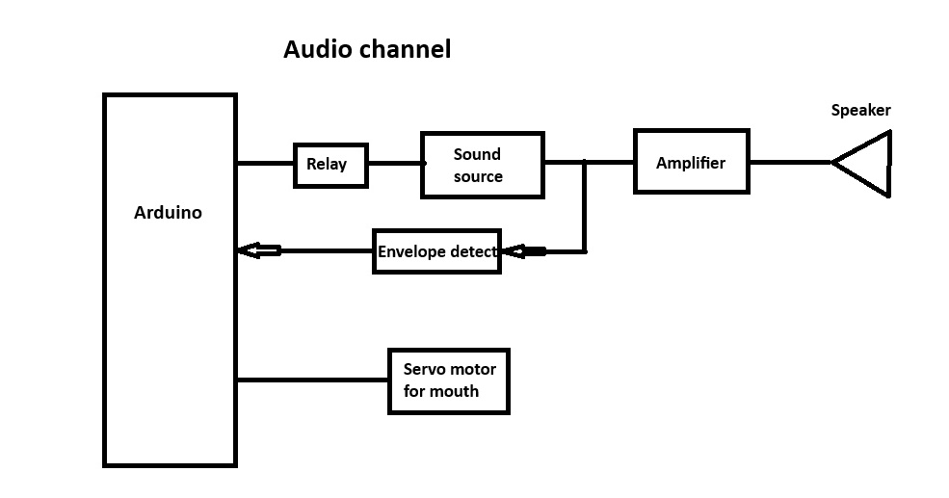
The audio card has an envelope detector which is used by the Arduino to calculate the PWM drive to the servo-driven mouth. This card has to be modified to remove the built-in microphone. This allows the audio signal to be fed directly into this card. The modification of this card is shown below:
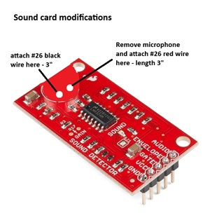
Arduino program
The Arduino program is divided into segments, with each segment having the option of enabling motion (forward, backwards, turn), eyeball rotations (7 eyeballs) and audio (cow and rooster sounds, Mars Attacks sounds).
Each segment is defined by a timer countdown. Ideally, each count will be around 20ms (50Hz), which is the best frequency for controlling servo motors. For example, segment 1A has the following time intervals in one count of "i";
motorsFwd = left motor =2.2ms + right motor = 2.2ms total = 4.4ms
delay = 11ms
rear mouth appx. = 1.5ms
total time = 16.9ms - this is fine for servo drives
In this case, segment 1A will last about 300*017 = 5.1 seconds
Segment 1A
Here's an example of a short segment. This segment starts with both motors forward and then enabling the cow sound with the rear mouth.
//__________________________________________________________________________ segment 1A
digitalWrite(Sound, LOW);
for (i = 0; i<=300; i++) {
//___________________________________________________ motors forward
fwd = 2200;
motorsFwd(fwd);
delay (11);
rearMouth(val1); //______________________________________rear mouth
if (i <50) {
digitalWrite(Cow, HIGH);
}
else {
digitalWrite(Cow, LOW);
}
if (i>150 && i < 200)
{digitalWrite(Cow, HIGH);
Mouth dynamics
The Arduino takes the output voltage from the sound card; val10 (envelope of audio) and converts it into a pulse width to drive the mouth servo motor. Here's the program for the front mouth of the Strandbeest.
int mult = 25;
float expt = .50;
void frontMouth(int val0) {
val0 = analogRead(0); //calculate pulseLength and limit its range
pulseLength = PulseMin+mult*pow(val0, expt);
if (pulseLength< PulseMin) pulseLength = PulseMin;
if (pulseLength> pulseMax) pulseLength = pulseMax;
digitalWrite(MOUTH, HIGH); //start servo pulse
delayMicroseconds(pulseLength);
digitalWrite(MOUTH, LOW);
Functions
The function for the motor drivers is shown. The other functions involving servo drives are similar.
void motorsFwd(int fwd) {
digitalWrite(motorL, HIGH); //pulse for left motor
delayMicroseconds(fwd);
digitalWrite(motorL, LOW);
digitalWrite(motorR, HIGH); //pulse for right motor
delayMicroseconds(fwd);
digitalWrite(motorR, LOW);
}
Eyeball rotation
The Strandbeest really needs to have rotating eyeballs. Here's how they are controlled.
int G = 6; Eyeball rotation constant
Eyeball function (eyeball A as example)
void A (int pulseEyeA) {
digitalWrite(eyeA, HIGH);
delayMicroseconds(pulseEyeA);
digitalWrite(eyeA, LOW);
}
Eyeball rotation shows rotation from counts 62 to 187 with different eyeballs rotating at different rates.
if (i >62.5 && i < 187.5) {
A (pulseEyeA);
pulseEyeA = pulseEyeA + G*2;
B (pulseEyeB);
pulseEyeB = pulseEyeB + G*1.9;
C (pulseEyeC);
pulseEyeC = pulseEyeC + G*2;
D (pulseEyeD);
pulseEyeD = pulseEyeD + G*2;
}
This has been a fun project. Every once in a while I'll put it out on the driveway and let it loose. It's awesome! Uncounted hours of effort with absolutely no practical value. The true definition of a hobby.

Code
Motorized Strandbeest
Controls motorized Stranbeest
redfescue
/
Strandbeest

